ECE3331

Signal Processing

Lab#2

Ziqin Shang

250890594

1. Down-sampling, Up-sampling and Reconstruction

1.Find the hourly price by up-sampling the daily data and plot it.

• (5 points) Use the MATLAB function interp.

See Appendix A - figure 1.

• (5 points) What are the differences between using MATLAB functions upsample and interp?

See Appendix A - figure 2.

The difference is that the interp spread the data apart then fill the values in between the gaps, which makes interp looks similar to the original graph but more spaced. Upsample works similar but the function fills in the data points with 0, which is the reason why the graph is shaded, since the plot goes from 0 to the set datapoint.

2. Find the weekly price by down-sampling the daily data and plot it.

• (5 points) Use the MATLAB function downsample.

See Appendix A - figure 3.

3. Use the weekly data obtained in the previous part and try to reconstruct the daily data by up-sampling the weekly data.

• (5 points) Plot the original daily data along with the reconstructed daily data in the same figure.

See Appendix A - figure 4.

• (5 points) Compare the results and discuss the differences

The results yielded by interpolated the downsampled signal is very similar to the original dataset, however it is not nearly as precise, with the sharp changes in values found in the original being smoother and more rounded in the reconstructed dataset.

• (5 points) Is it possible to reconstruct the exact daily data? Explain your answer.

No, it is not possible to reconstruct the exact same data because some information is lost during the process of upsampling. Due to that fact, we could only guess the value in between, but it is never possible to reconstruct the original data exactly via downsampling or upsampling.

2. Discrete-time Systems and z-Transform

1. Assume a discrete-time system described by the difference equation: y[n + 1] = y[n] + cx[n]

(a) (5 points) Assuming x[.] is the system input and y[.] is the system output and c = 0.01, find the z-transform representation of this system.

(b) (5 points) Draw a direct form I realization structure for this system.

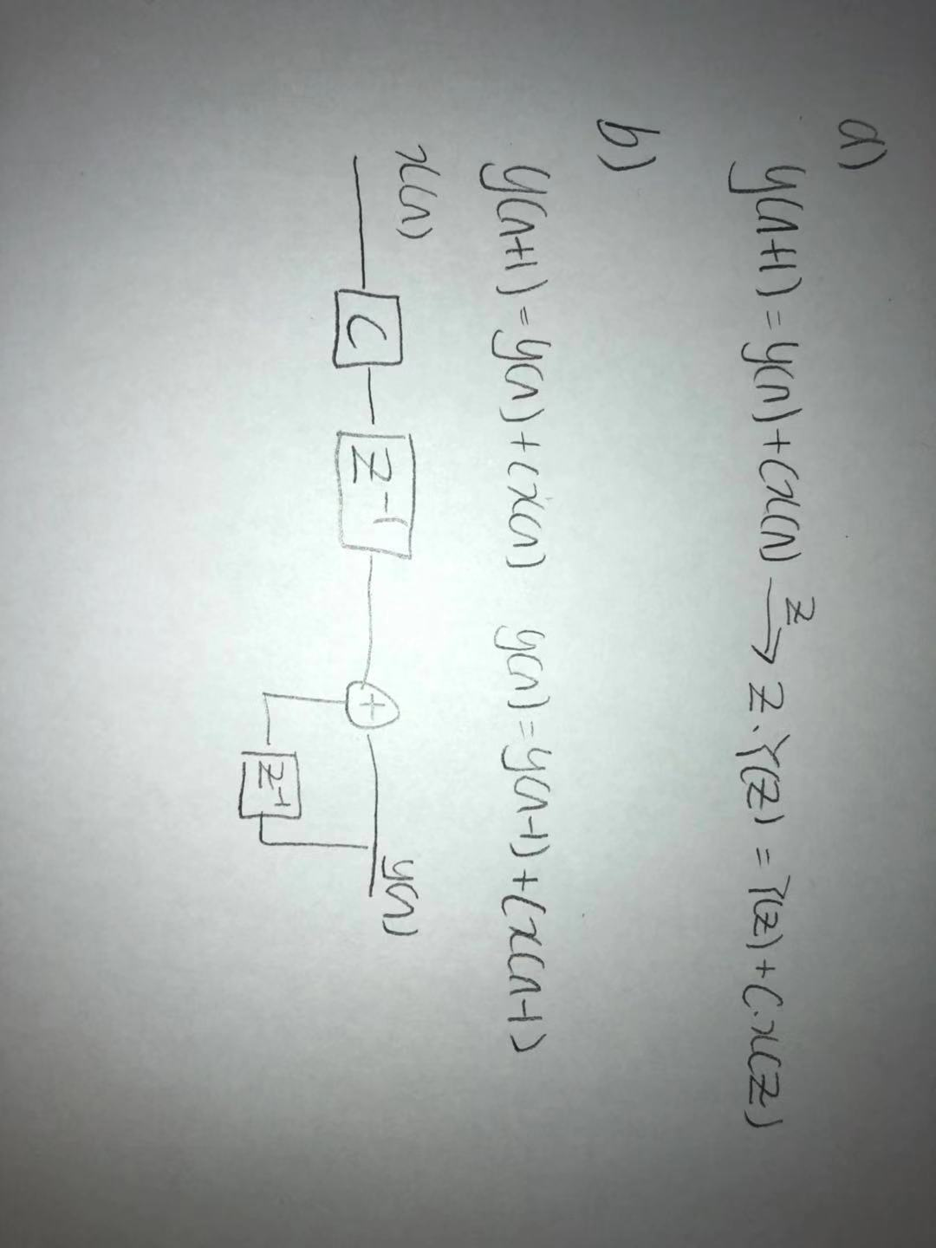

(c) (5 points) Implement this system in a Subsystem block in Simulink, based on its block diagram. You can use the following Simulink blocks to realize the system: Gain, Sum and Unit Delay. Ts = 0.01 is the sampling period.

See Appendix A - figure 5.

(d) (5 points) Generate a square-wave input (amplitude = 1 and frequency = 1Hz) using the Signal Generator block in Simulink, take it as an input to the system and run the simulation to see both input and output signals on a Scope. A sample Simulink model is shown in the figure below.

See Appendix A - figure 6.

(e) (5 points) Replace the Subsystem by a Discrete Transfer Fcn block (using the z-Transform of the system) and run the simulation. Does it generate the same output as the delay-diagram simulation?

See Appendix A - figure 7,8. They generated same output.

(f) (5 points) Repeat the last two parts for a sinusoidal-wave with the same amplitude and frequency.

See Appendix A - figure 9-12.

(g) (5 points) This system is called a discrete-time integrator. How can you describe this based on the simulation results for the square-wave and sinusoidal wave signals?

Based on the simulation result, the discrete-time integrator can be described as modifying a square wave input, which varies from +1 to -1,into sawtooth waveform and modifying sinusoidal waveform into a sinusoidal waveform with lower amplitude. For the sinusoidal waveform, the integral of sine is negative cosine. In the waveform, this bene waveform reaches 0, the output waveform is at its maximum amplitude.

2. (15 points) For the following transfer function T2(z) = 1 − a 1 − az−1

obtain the step-response in Simulink for a = 2, ±0.9, ±0.1 and compare the results. Describe the relationship between the obtained results and position of the poles of the system in z-plane.

See Appendix A - figure 13-17.

The system is considered stable if all of the poles in the system transfer function lie within the unit circle. In this case, the poles are all inside of the unit circle, but the system experienced overshoot due to underdamping. Likewise, systems with poles inside the unit circle but on the right half plane are overdamped and thus experience no overshoot but take longer to reach the reference signal.

@z = 2 outside the unit circle: the system grows without bound

@z = 0.9 inside the unit circle, the system grows but eventually stops at a constant value

@z = -0.9, the system oscillates but eventually decays to a constant value too; this characteristic continues for z = 0.2 and z = 0.2, the system oscillates in both cases, but eventually decays to a constant value.

3. For the following transfer function T3(z) = 1 1 − 2b cos(ω0Ts)z −1 + b 2z

obtain the step-response in Simulink for b = 0.99 and ω0 = 25, 50, 100 rad/s and compare the results. Assume Ts = 0.01 s is the sampling period. Answer the following questions based on the simulation results:

• (10 points) Draw the location of the zeros and poles of the system in the z-plane in each case. You can use the MATLAB functions pzmap and tf.

• (10 points) Calculate the oscillation frequency of the step response for each case, based on the location of the system poles in the zplane. Measure the oscillation frequency of each step response using the simulation results and compare them to the calculated values.

See Appendix A - figure 18-21.

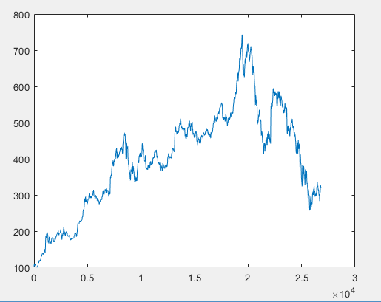

Figure 1: Q1 Plot of Hourly Price using Interp()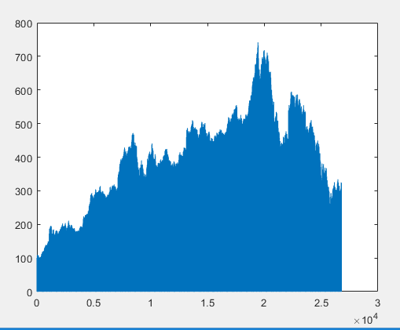

Figure 2: Q1 Plot of Hourly Price using Upsample()

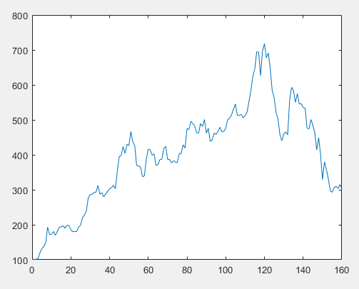

Figure 3: Q2 Plot of Weekly Price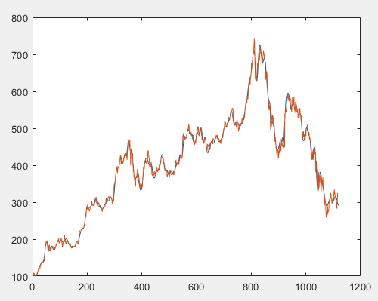

Figure 4: Plot of Original and Reconstructed Data

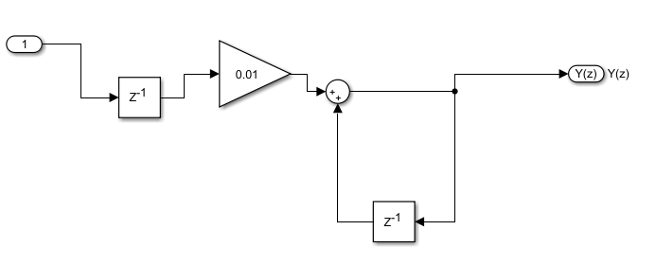

Figure 5: Subsystem Block

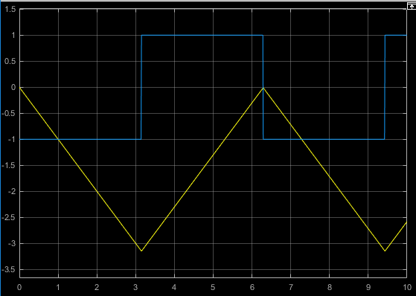

Figure 6: Delay-Diagram Simulation

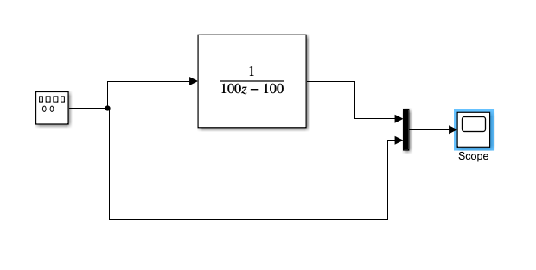 Figure 7: Discrete Transfer Function 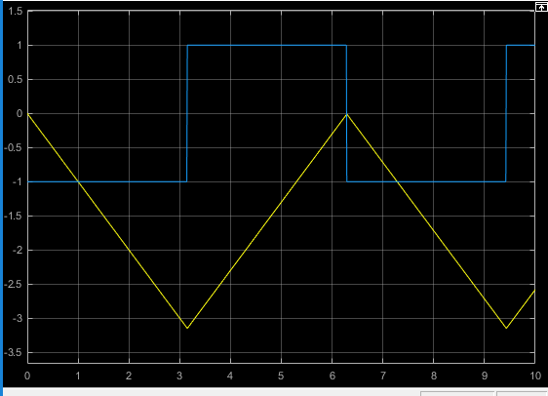

Figure 8: Discrete Transfer Function Simulation

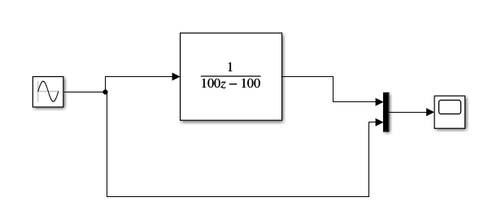Figure 9: Discrete Transfer Function 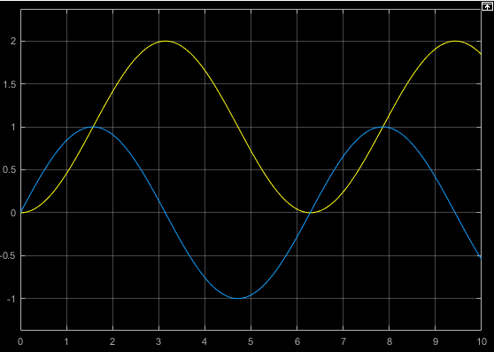

Figure 10: Discrete Transfer Function Simultion with Sinusoidal Waveform

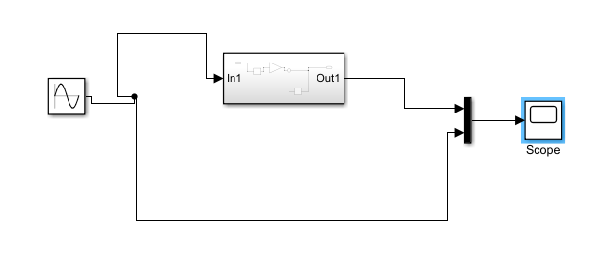Figure 11: Delay-Diagram Schematic with Sinusoidal Waveform 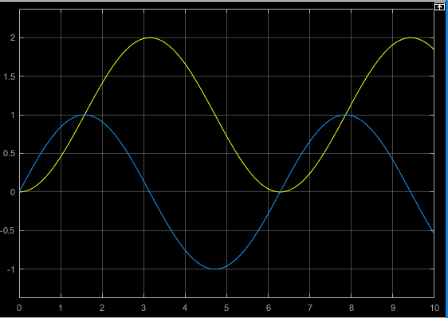

Figure 12: Delay-Diagram Schematic with Sinusoidal Waveform

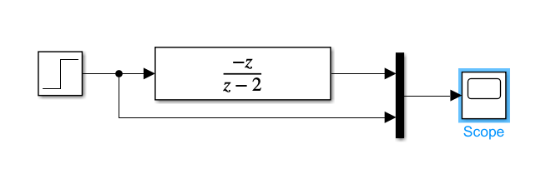

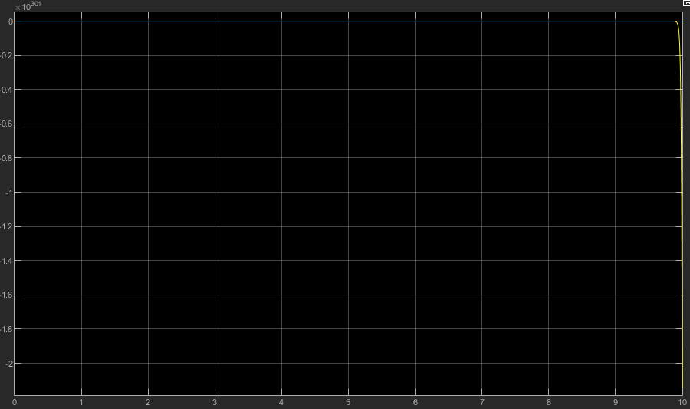

Figure 13: a=2

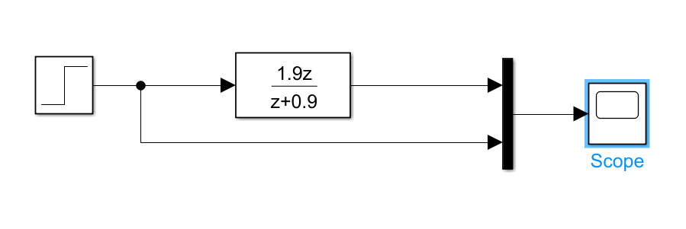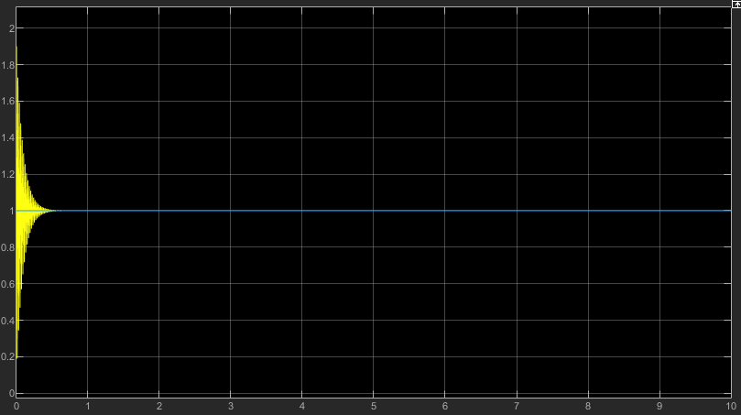

Figure 14: a=-0.9

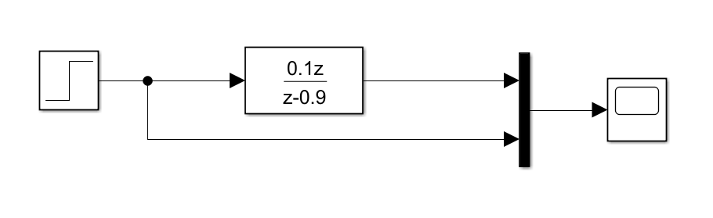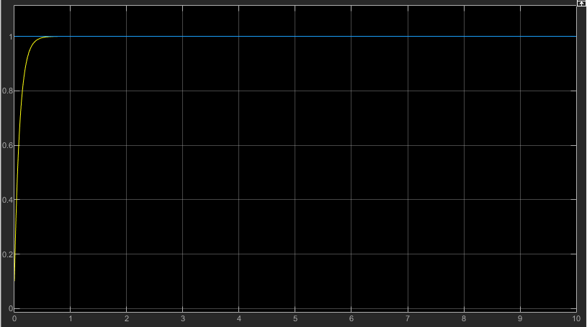

Figure 15: a=0.9

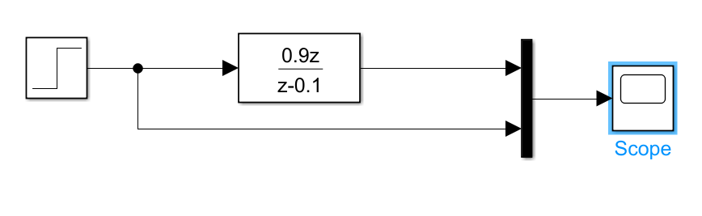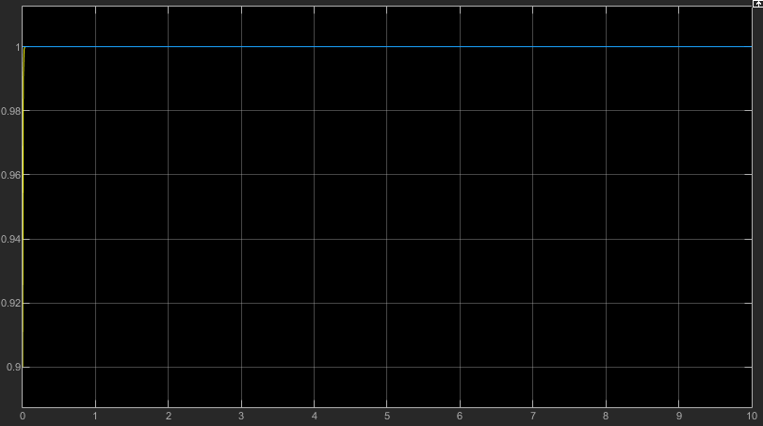

Figure 16: a=0.1

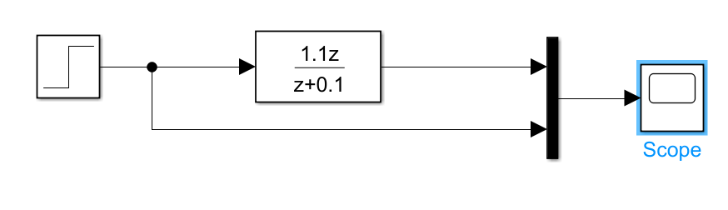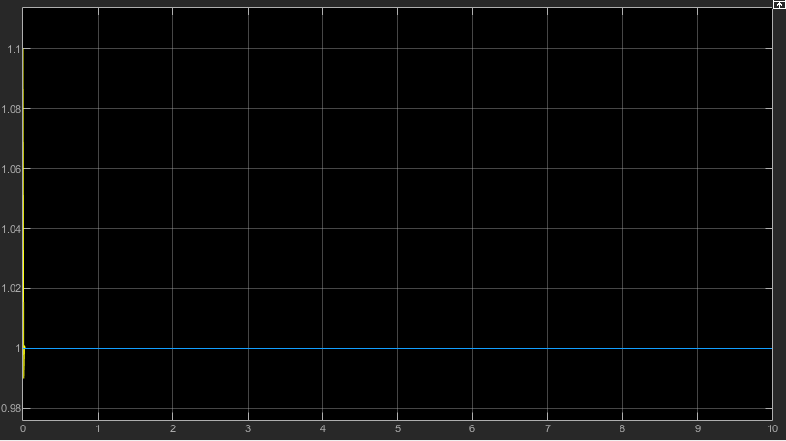 Figure 17: a=-0.1

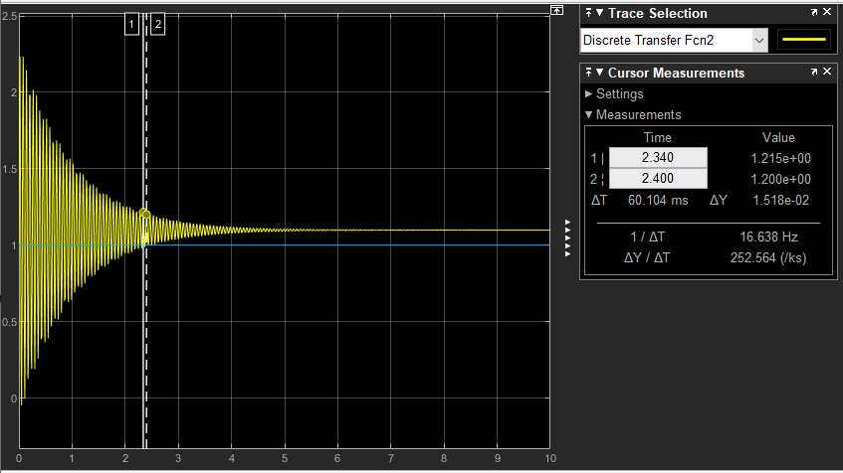

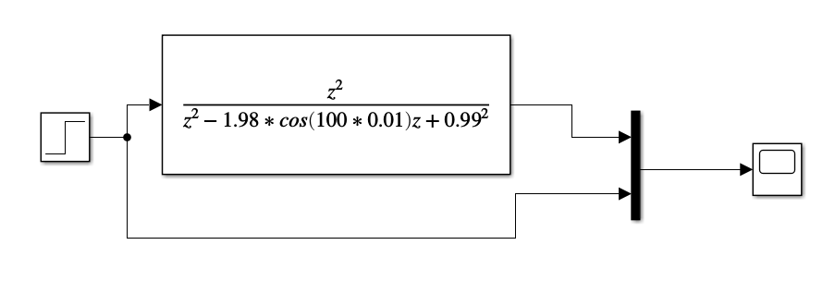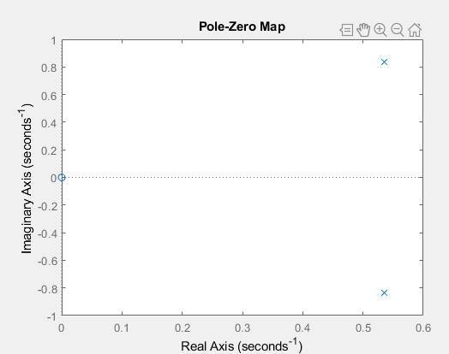

Figure 18: W0 = 100 rad/s

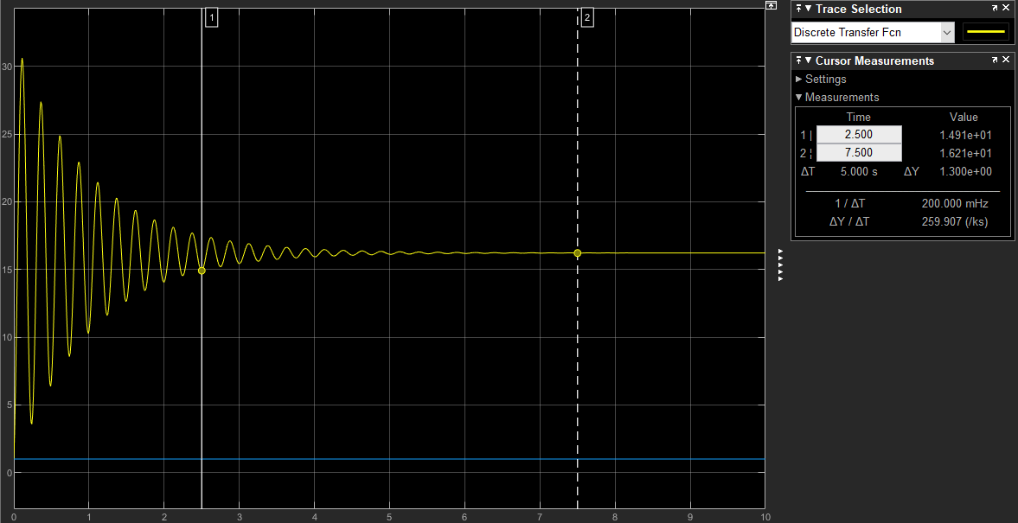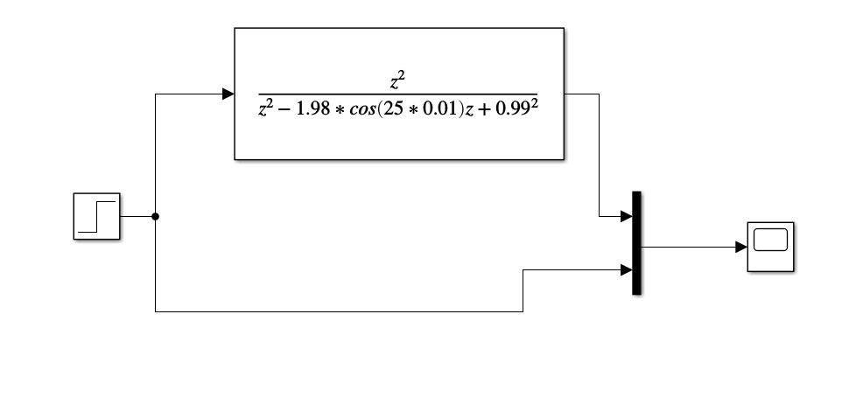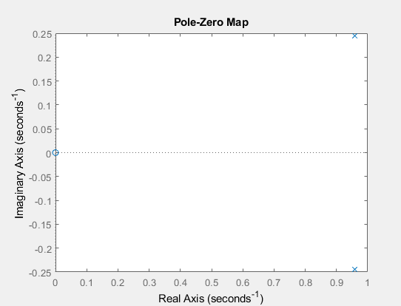

Figure 19: W0 = 25 rad/s

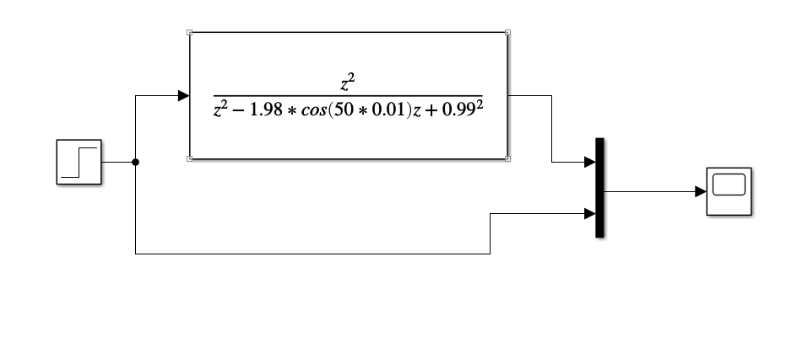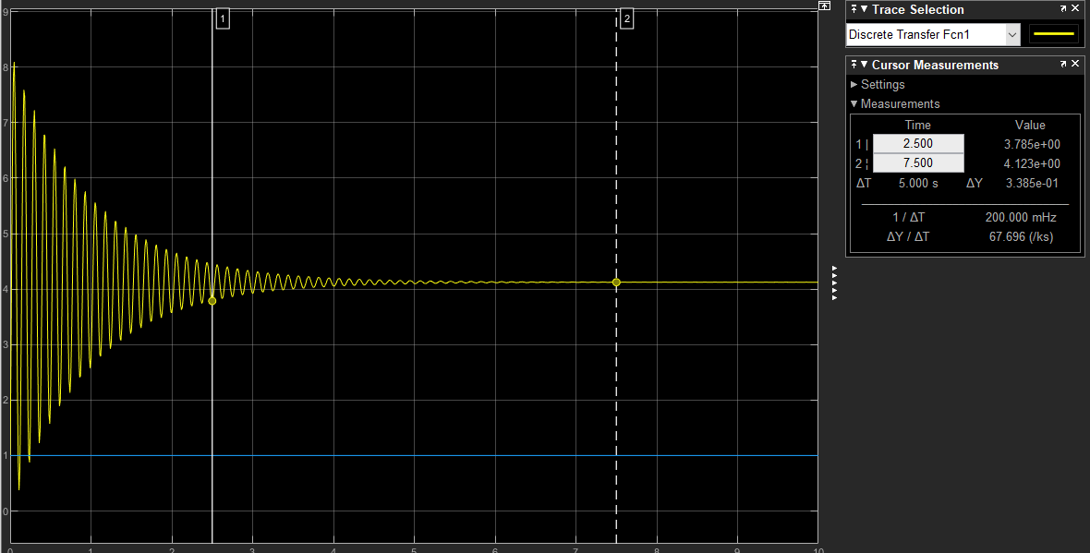

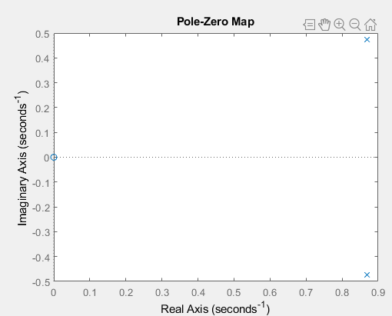

Figure 20: W0 = 50 rad/s

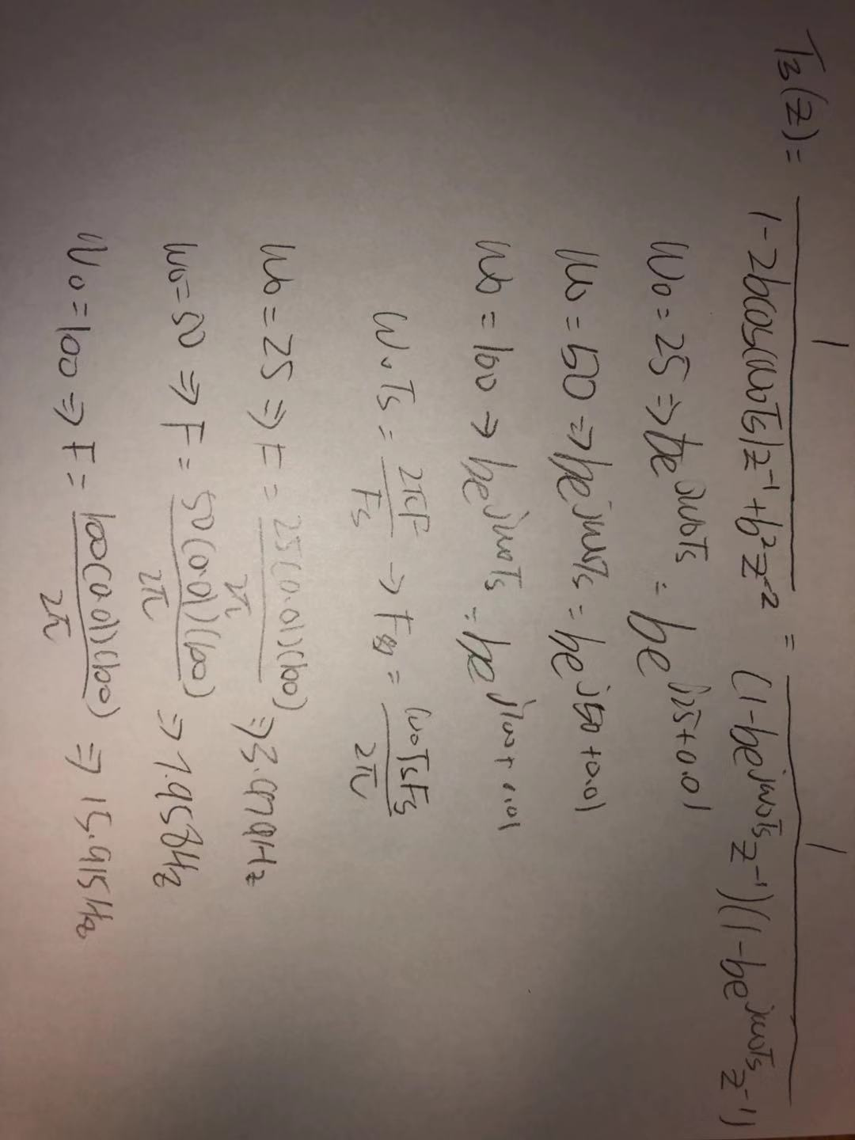

Figure 21: frequency calculations